Name

Mathematics Stage 5 Paths
Factorising Negative and Algebraic Factors

Book 1 |  | Version: 261002  Feedback:  https://MrDingMaths.com
Contents
Syllabus Content 2
Learning Intention 3

Syllabus Content
MA5-ALG-P-01 simplifies algebraic fractions involving indices, and expands and factorises algebraic expressions
Factorise algebraic expressions by taking out a common algebraic factor
- Factorise algebraic expressions, including those involving indices, by determining the highest common factors (HCF) including negative coefficients/pronumerals

Factorising a Negative HCF

- Factorising a Negative HCF
To factorise with a negative HCF:
- Identify the negative highest common factor (HCF) of the terms.
Write it outside brackets.
- Divide each term by the HCF. Put the results inside the brackets.

You should factor out a negative HCF if both terms are negative, or if the question asks for it.
This skill is used in a later topic (factorising by grouping in pairs).

- Example Factorise by finding a finding a negative HCF
Factorise these expressions by finding a negative HCF.
$-8x-16$  1. $-8( )$  2. $-8(x+2)$ | $12x-4xy$  1. $-4x( )$  2. $-4x(-3+y)$

- Guided Practice
Factorise these expressions by finding a negative HCF.
- $-8x-4$  $=-4( )$  $$-4\left(2x+1\right)$$ | - $-2m+4n$  $=-2( )$  $$-2\left(m-2n\right)$$ | - $-3xy+18x$  $$-3x\left(y-6\right)$$
- $8x^{2}-12x$  $$-4x\left(-2x+3\right)$$ | - $6x-20x^{2}$  $$-2x\left(-3+10x\right)$$ | - $5a^{3}x+10a^{2}$  $$-5a^{2}\left(-ax-2\right)$$

Foundation
- Complete these factorisations.
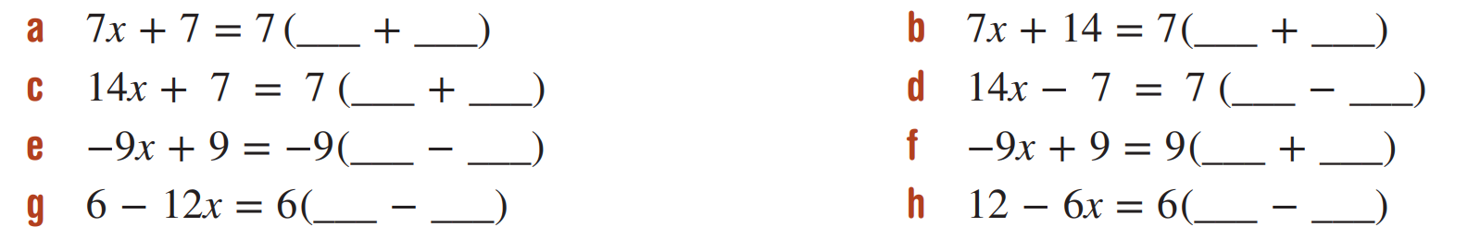  $$x, 1$$ | $$2x, 1$$ | $$2x, 1$$
$$x, 1$$ | $$-x, 1$$ | $$1, 2x$$

- Factorise by taking out a negative HCF.
- $-8x-4$  $$-4\left(2x+1\right)$$ | - $-4x-2$  $$-2\left(2x+1\right)$$ | - $-10x-5y$  $$-5\left(2x+y\right)$$
- $-7a-14b$  $$-7\left(a+2y\right)$$ | - $-9x-1$  $$-\left(9x+1\right)$$ | - $-6y-8$  $$-2\left(3y+4\right)$$
- $-10x-15y$  $$-5\left(2x+3y\right)$$ | - $-4m-20n$  $$-4\left(m+5n\right)$$ | - $-3x^{2}-18x$  $$-3x\left(x+6\right)$$
- $-6x+8$  $$-2\left(3y-4\right)$$ | - $-12x+16$  $$-4\left(3x-4\right)$$ | - $-60x+45$  $$-15\left(4x+3\right)$$
- $-9x-12$  $$-3\left(3x+4\right)$$ | - $-20xy+15x$  $$-5x\left(4y-3\right)$$ | - $21x-15xy$  $$3x\left(7-5y\right)$$

- Read the examples carefully and answer the questions.
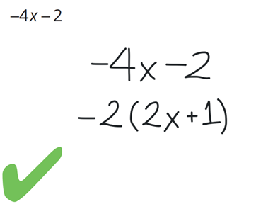  Fei’s work | Where did the +1 come from in Fei’s factored expression?  $-2$ divided by ……… is 1  Factorise:  $$-9x^{2}-3x$$  $$-3x\left(3x+1\right)$$

Development
- Factorise the following. For these questions, always take out a negative HCF.
- $3x-18$  $$-3(-x+6)$$ | - $-12a-3$  $$-3\left(4a+1\right)$$ | - $-5x-30$  $$-5\left(x+6\right)$$
- $10a-5a^{2}$  $$-5a\left(-2+a\right)$$ | - $4x^{2}+x$  $$-x\left(-4x-1\right)$$ | - $6b^{2}-18b$  $$-6b\left(-b+3\right)$$
- $12x-30x^{2}$  $$-6x\left(-2+5x\right)$$ | - $-2x-x^{2}$  $$-x\left(2+x\right)$$ | - $-4y-8y^{2}$  $$-4y\left(1+2y\right)$$
- $6xyz^{2}+3z^{2}$  $$-3z^{2}\left(-2xy-1\right)$$ | - $2x^{2}yz-4xy$  $$-2xy\left(-xz+2\right)$$ | - $-12m^{2}n-12mn^{2}$  $$-12mn\left(m+n\right)$$
- $-16y^{2}-6y$  $$-2y\left(8y+3\right)$$ | - $-5a^{2}-10a$  $$-5a\left(a+2\right)$$ | - $-6x-20x^{2}$  $$-2x\left(3+10x\right)$$
- $-6p-15p^{2}$  $$-3p\left(2+5p\right)$$ | - $-16b-8b^{2}$  $$-8b\left(2+b\right)$$ | - $-9x-27x^{2}$  $$-9x\left(1+3x\right)$$

- Many of the following expressions are not fully factorised. Finish the factorisation.
- $2(3x+9)$  $=2×3\left(x+3\right)$  $=$  $$6\left(x+3\right)$$ | - $2(6x-12)$  $$12\left(x-2\right)$$ | - $4(12-6x+4y)$  $$8\left(6-3x+2y\right)$$
- $2(-3x-9)$  $$-6\left(x+3\right)$$ | - $2(12-6x)$  $$12\left(2-x\right)$$ | - $4(12-6x+5y)$  can’t factorise further
- $2(6x+10)$  $$4\left(3x+5\right)$$ | - $4(-12-6x)$  $$-24\left(2+x\right)$$ | - $4(12x-6x^{2}+5xy)$  $$4x\left(12-6x+5y\right)$$
- $2(6x+11)$  can’t factorise further | - $4(12-6x+2y)$  $$8\left(6-3x+y\right)$$ | - $4(12x-6x^{2}+4xy)$  $$8x\left(6-x^{2}+2y\right)$$
- $2(-6x-12)$  $$-12\left(x+2\right)$$ | - $4(12-6x+3y)$  $$12\left(4-2x+y\right)$$ | - $4(12x^{2}-6x^{2}+5x^{2}y)$  $$4x^{2}\left(6+5y\right)$$

Mastery
- Common factors can also be removed from expressions with more than two terms.
For example: $2x^{2}+6x+10xy=2x\left(x+3+5y\right)$. Factorise these expressions.
- $3a+9b+12$  $$3\left(a+3b+4\right)$$ | - $5z^{2}-10z+zy$  $$z\left(5z-10+y\right)$$ | - $x^{2}-2xy+x^{2}y$  $$x\left(x-2y+xy\right)$$
- $4by-2b+6b^{2}$  $$2b\left(2y-1+3b\right)$$ | - $-12xy-8yz-20xyz$  $$-4y\left(3x+2z+5xz\right)$$ | - $3ab+4ab^{2}+6a^{2}b$  $$ab\left(3+4b+6a\right)$$

- Sometimes we can choose to factor out a negative or a positive HCF.
Both factorisations are correct. For example:
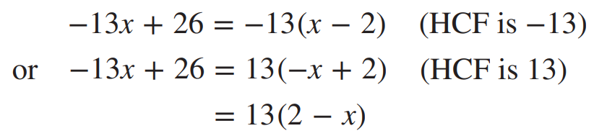

Factorise these expressions in two ways.
- $-4x+12$  $$4\left(-x+3\right),$$  $$-4\left(x-3\right)$$ | - $-3x+9$  $$3\left(-x+3\right),$$  $$-3\left(x-3\right)$$ | - $-8n+8$  $$8\left(-n+1\right),$$  $$-8\left(n-1\right)$$
- $-5m+5m^{2}$  $$5m\left(-1+m\right),$$  $$-5m\left(1-m\right)$$ | - $-7x+7x^{2}$  $$7x\left(-1+x\right),$$  $$-7x\left(1-x\right)$$ | - $-4y+22y^{2}$  $$2y\left(-2+11y\right),$$  $$-2y\left(2-11y\right)$$
- $-8n+12n^{2}$  $$4n\left(-2+3n\right),$$  $$-4n\left(2-3n\right)$$ | - $-8y+20$  $$4\left(-2y+5\right),$$  $$-4\left(2y-5\right)$$ | - $-15mn+10$  $$5xy\left(-2y+3x\right),$$  $$-5xy\left(2y-3x\right)$$
- $9x-27x^{2}$  $$9x\left(1-3x\right),$$  $$-9x\left(-1+3x\right)$$ | - $16ab-8ab^{2}$  $$8ab\left(2-b\right),$$  $$-8ab\left(-2+b\right)$$ | - $-10xy^{2}+15x^{2}y$  $$5xy\left(-2y+3x\right),$$  $$-5xy\left(2y-3x\right)$$
- $x^{2}y-4xy+xy^{2}$  $$xy\left(x-4+y\right),$$  $$-xy\left(-x+4-y\right)$$ | - $6ab-10a^{2}b+8ab^{2}$  $$2ab\left(3-5a+4b\right),$$  $$-2ab\left(-3+5a-4b\right)$$ | - $-3a^{3}b+12ab^{2}+9a^{2}b^{3}$  $$3ab\left(-a^{2}+4b+3ab^{2}\right),$$  $$-3ab\left(a^{2}-4b-3ab^{2}\right)$$

